**The Perfect Pour: Exploring the Interaction Between Price, ABV, and Aging in Bourbon Ratings.**

This project investigates the factors influencing bourbon ratings using a dataset that I personally created from WhiskeyAdvocate.com. The dataset includes variables such as price, alcohol by volume (ABV), aging period, actual ratings, and predicted ratings. Using my knowledge from a statistics course, I developed a regression model to generate predicted ratings for each bourbon. The central question is: How do price, ABV, and aging period interact to affect bourbon ratings?

The hypothesis is that bourbon ratings are driven by the interplay of price, ABV, and aging period. While aging and ABV are expected to correlate positively with ratings, price may show inconsistencies due to subjective consumer preferences and branding. The goal of this project is to visualize these relationships and uncover patterns in high-rated bourbons.

Studies on consumer preferences for spirits highlight the importance of aging and ABV in determining perceived quality. Price often shows mixed correlations, with branding influencing consumer perception more than intrinsic quality. This project builds on such findings by incorporating a correlation matrix to reveal statistical relationships and using box plots and rankings to uncover trends in bourbon ratings.

1. **Correlation Analysis**:

* **ABV and Ratings**: A strong positive correlation indicates that higher ABV levels are generally associated with higher ratings.
* **Aging Period and Ratings**: A moderate positive correlation shows that bourbons with longer aging periods tend to have better ratings.
* **Price and Ratings**: A weak correlation suggests that price does not strongly predict ratings, meaning expensive bourbons do not always score higher.
* **Predicted vs. Actual Ratings**: A high correlation validates the regression model, showing alignment between predicted and actual ratings overall.

1. **Ranking Analysis**:

* These bourbons have actual ratings significantly higher than their predicted ratings, highlighting standout performers that exceed expectations.

* These bourbons have actual ratings lower than predicted ratings, showing underperformers based on the regression model.

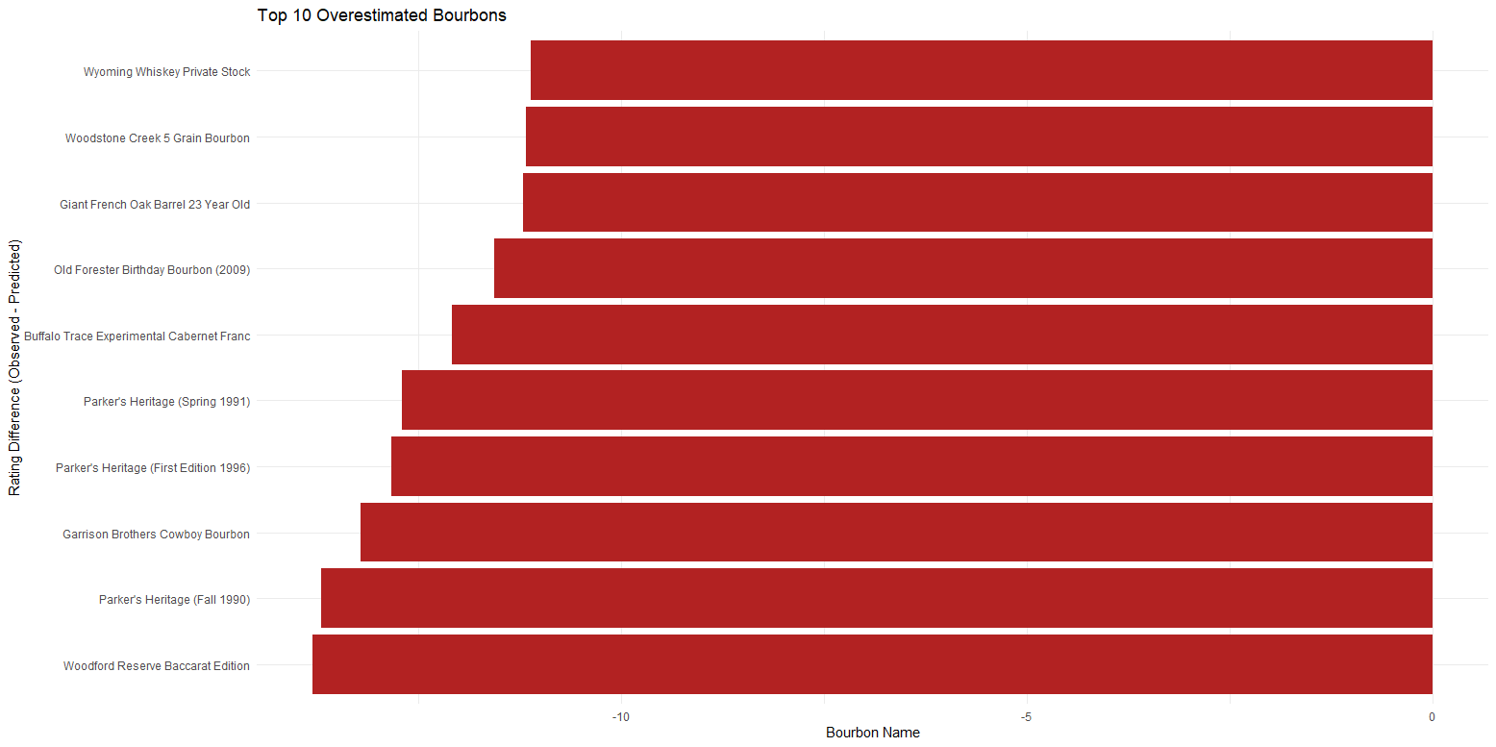

* These bourbons offer the best ratings relative to their price, representing optimal value for consumers.

* These bourbons have high prices but lower actual ratings, emphasizing perceived overvaluation.

1. **Distribution Analysis:**

* High-rated bourbons have a higher median ABV compared to lower-rated bourbons.
* The spread of ABV is narrower for high-rated bourbons, indicating less variability in preferred ABV levels.
* ABV levels above 70% show a noticeable drop in ratings, suggesting that extremely high alcohol content may not appeal to most consumers or align with preferences for balance.

* Bourbons with longer aging periods have higher median ratings, indicating a positive relationship between aging and perceived quality.
* Variability in ratings is more pronounced for shorter-aged bourbons, reflecting inconsistent performance in this group.
* The highest-rated bourbons show a tighter spread in ratings, suggesting consistency in quality among longer-aged products.

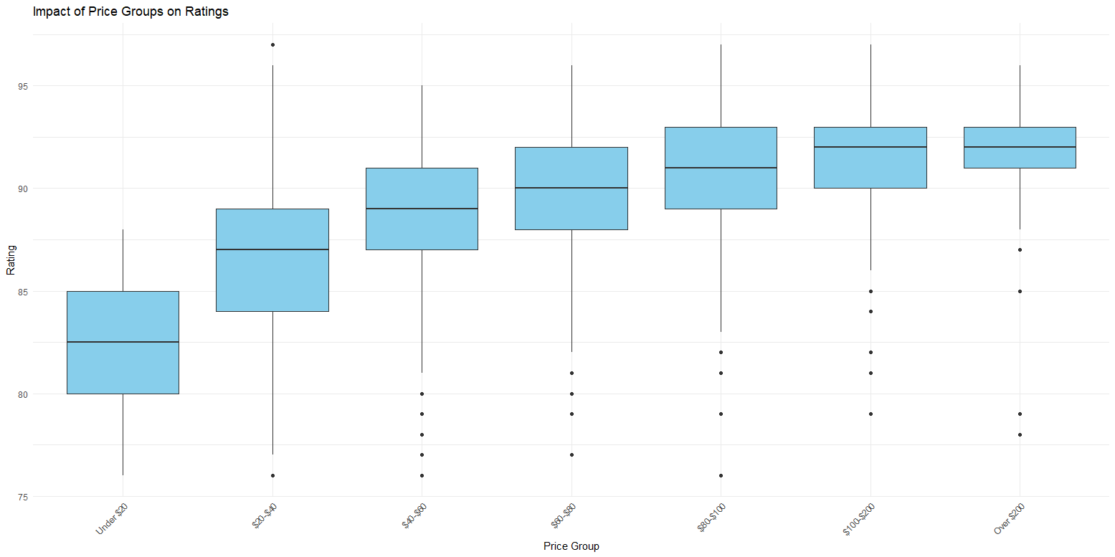

* Bourbons in the **$100–$200** price range have the highest median ratings, suggesting that premium pricing within this range is associated with higher perceived quality.
* Bourbons priced **under $20** have the lowest median ratings, indicating that lower pricing is generally linked to lower quality.
* Variability in ratings is greater in the **over $200** price group, reflecting inconsistent quality at the highest price points.
* Mid-range bourbons ($40–$100) show consistent performance, with narrower interquartile ranges and fewer outliers compared to lower or higher price groups.

1. **Multivariate Visualization:**

* Under 40% ABV: Bourbons in this group have lower median ratings, with younger aging groups (e.g., 0–5 years) performing the poorest.
* 40–45% ABV: Ratings improve slightly across all aging groups. Bourbons aged 15–20 years or more have noticeably higher ratings.
* 45–50% ABV: A strong improvement in ratings, particularly for bourbons aged 10–15 years and 15–20 years. This range shows consistent quality for these aging groups.
* 50–55% ABV: High ratings are observed across most aging groups, with minimal variability in the longer-aged categories.
* 55–60% ABV: Consistently high ratings, particularly for bourbons aged 15–20 years and 20+ years.
* 60–65% ABV: Ratings remain high, though variability increases for younger aging groups.
* 65–70% ABV: A noticeable decline in ratings for bourbons aged 0–5 years and 5–10 years, while longer-aged bourbons maintain strong performance.
* 70%+ ABV: Ratings become more inconsistent, with longer-aged bourbons still achieving relatively high scores but younger ones performing poorly.

* Under 40% ABV: Ratings are generally lower across all price groups. Bourbons in the $40–$60 price group perform slightly better than other price ranges.
* 40–45% ABV: Ratings improve, particularly for bourbons in the $60–$80 and $100–$200 price groups. Variability in ratings is noticeable, with outliers in lower-priced bourbons.
* 45–50% ABV: A significant improvement in ratings, particularly for bourbons in the $60–$80, $80–$100, and $100–$200 price groups. Lower-priced bourbons (Under $20 and $20–$40) underperform in this ABV range.
* 50–55% ABV: Consistently high ratings across most price groups, with the $60–$80 and $80–$100 groups performing the best. Minimal variability is observed for higher-priced bourbons in this ABV range.
* 55–60% ABV: Ratings remain high, with bourbons in the $80–$100 and $100–$200 groups achieving the highest scores. Variability increases for lower-priced bourbons ($20–$40).
* 60–65% ABV: Ratings are consistent across mid- to high-priced groups ($60–$80, $80–$100, and $100–$200). Lower-priced bourbons ($20–$40) show a slight decline in ratings.
* 65–70% ABV: A slight dip in ratings is observed across most price groups, particularly for lower-priced bourbons.
* 70%+ ABV: Ratings become more variable, with some high-priced bourbons (Over $200) achieving lower scores compared to mid-priced groups ($60–$80 and $100–$200).

* Under $20: Bourbons in this price range generally have the lowest ratings. The Under 40% ABV and 40–45% ABV groups perform poorly, while slight improvements are seen for the 50–55% ABV group.
* $20–$40: Ratings improve across most ABV groups, with higher performance in the 50–55% ABV and 55–60% ABV groups. Variability increases, with outliers in both the lower and higher ABV ranges.
* $40–$60: This price range sees consistently higher ratings, particularly for bourbons in the 50–55% ABV, 55–60% ABV, and 60–65% ABV groups. Lower ABV groups (Under 40%) continue to underperform.
* $60–$80: High ratings persist across most ABV groups, especially for 55–60% ABV and 60–65% ABV groups. Variability begins to increase slightly in higher ABV ranges.
* $80–$100: Strong ratings are observed for bourbons in the 60–65% ABV group. A slight decline appears in the 65–70% ABV group.
* $100–$200: High ratings are maintained, especially in the 55–60% ABV and 60–65% ABV groups. Variability decreases compared to the $80–$100 range, indicating more consistency.
* Over $200: Ratings become more inconsistent. High-performing bourbons are found in the 55–60% ABV group, while 70%+ ABV bourbons show lower ratings.

**Conclusion**

This project successfully visualized the interplay between bourbon attributes—price, ABV, aging period—and their impact on ratings using a self-curated dataset from WhiskeyAdvocate.com. Through detailed analysis, insights were derived that showcase how these factors interact to influence bourbon quality.

Key findings include:

* **Aging Period**: Longer aging periods consistently lead to higher ratings, with bourbons aged 15–20 years achieving the most consistent performance.
* **ABV**: Bourbons in the 50–60% ABV range are associated with the highest ratings across most price groups, while extremely high ABV (70%+) leads to more inconsistent ratings.
* **Price**: Mid-range price groups, particularly $100–$200, deliver the best balance of high ratings and consistency, while both low-priced bourbons and ultra-premium options (over $200) show greater variability in quality.

The visuals, including correlation matrices, box plots, and interaction plots, effectively communicate these relationships and make complex interactions accessible. By combining statistical modeling and visualization, this project highlights optimal bourbon characteristics for enthusiasts and value-conscious consumers.

This analysis not only confirms the importance of aging and ABV in perceived bourbon quality but also demonstrates the limitations of price as a predictor of ratings. These findings can inform both consumers and producers about trends in bourbon appreciation and help identify key areas for exploration in future studies.